**Ernst Jünger (1895 – 1998)**

Ernst Jünger was a German writer of war accounts, diaries, novels, and political and theoretical essays. Although Jünger’s body of work is broad and varied, he is most often associated with his work of the 1920s and 1930s, which embraces an aesthetic of war, destruction, pain, and technology as the key to aesthetic and experiential fulfillment.

Jünger was born to a middle-class family in Heidelberg, and grew up in Hannover. After serving briefly with the French Foreign Legion, Jünger volunteered at the outbreak of World War I and served in the German army on the Western Front for the duration of the war. He was wounded several times and, among other awards, received the Pour le Mérite—the highest military honor at the time. Jünger’s war experiences serve as the basis for much of his literary work during the 1920s and 1930s. *In Stahlgewittern* [*Storm of Steel*], first published in 1920 and re-issued in no less than seven editions up until 1979, describes the sights, sounds, and experiences of trench warfare. The book is noted for its objective, and often distanced, account of battlefield experience. His other works during this period include other memoirs, contributions to military training manuals, and political and theoretical essays, which often appeared in right-wing journals. In *Kampf als inneres Erlebnis* (1922), *Feuer und Blut* (1925), *Die Totale Mobilmachung* (1931) [Total Mobilization], *Der Arbeiter* (1932), and *Über den Schmerz* (1934) [On Pain], Jünger theorizes transcendence through pain and violence, as well as a social order based on an embracing of warfare and on a symbiosis with visual technology. Jünger also contributed essays to, and assisted in, the editing of photography volumes during this period, including *Der gefährliche Augenblick* (1931), and *Die veränderte Welt* (1933).

Jünger both utilized and reacted to modernist literary forms. His oeuvre contains aspects of new objectivity, expressionism, and magical realism. Although his work was held in esteem by the Nazis, Jünger distanced himself from the National Socialist Movement. His 1939 *Auf den Marmorklippen [On the Marble Cliffs]* is often interpreted as a parable of the failures of the movement. Jünger’s later works include his diaries in *Strahlungen* (1949), the science fiction work, *Gläserne Bienen (1957) [The Glass Bees]*, and an account of his experiments with LSD, entitled *Annäherungen: Drogen und Rausch (*1970). The ideological underpinnings of his early work have made Jünger a controversial literary and social figure in Germany, although he remained a highly respected member of literary and intellectual circles throughout his life. He received numerous awards, including the Goethe Prize, one of Germany’s highest literary distinctions. He wrote prolifically until his death in 1998.

**Key Works**

*In Stahlgewittern* (1920, *Storm of Steel* 1929)

*Der Arbeiter: Herrschaft und Gestalt* (1932)

*Auf den Marmorklippen* (1939*, On the Marble Cliffs* 1947)

*Gläserne Bienen* (1957, *The Glass Bees*, 1960)

*Aladins Problem* (1983, *Aladdin’s Problem*,1992)

**References and Further Readings**

Neaman, E.Y. (1999) *A Dubious Past: Ernst Jünger and the Politics of Literature after Nazism*, Berkeley: University of California Press.

Nevin, T. (1996) *Ernst Jünger and Germany: Into the Abyss, 1914-1945,* Durham: Duke University Press.

Schwilk, H. (2010) *Ernst Jünger: Ein Jahrhundertleben*, Munich: Piper Verlag.

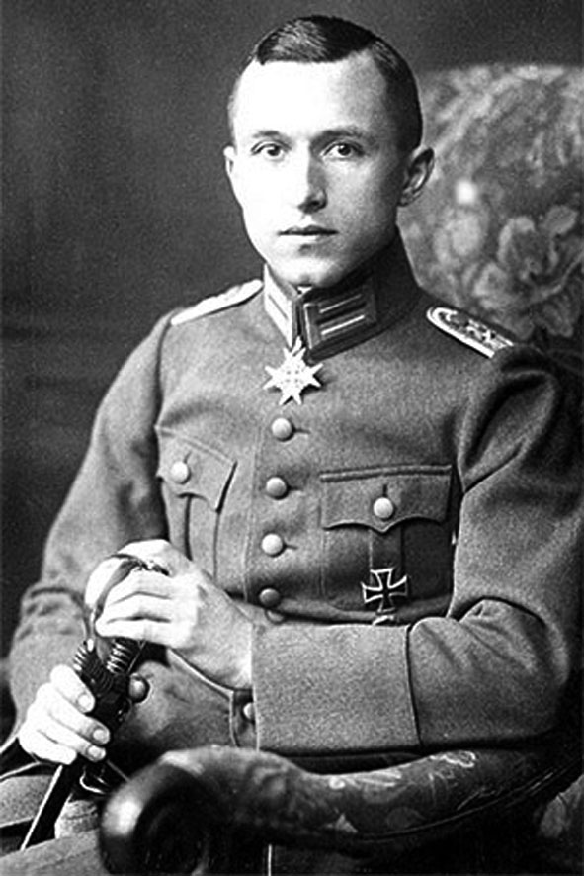

Picture from: Jünger Haus Wilflingen <http://www.juenger-haus.de/1895-1920,103.html>

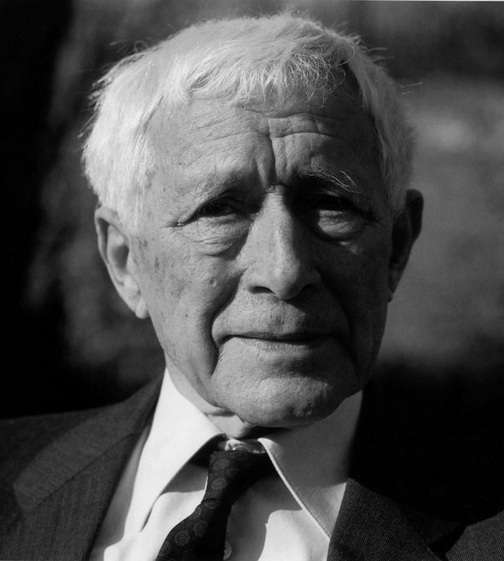

Picture from: Jünger Haus Wilflingen <http://www.juenger-haus.de/ernst-juenger,10.html>